Star-Ring Topology

What Is Star-Ring Topology?
# Source: AI Source: Provided by: [Data Path: Persons Table -> ID Column: 1, Name_En Column: Motasem Essam] -> From: [ChatGPT] on [12/18/2025]
A Star-Ring Topology is a type of hybrid network topology that combines elements of both Star and Ring topologies. It typically uses star layouts for local device connections, and those star networks are connected in a ring pattern.

🧠 Simple Definition:
# Source: AI Source: Provided by: [Data Path: Persons Table -> ID Column: 1, Name_En Column: Motasem Essam] -> From: [ChatGPT] on [12/18/2025]
In Star-Ring topology, individual star networks (with a central switch or hub) are linked together in a ring structure, allowing both local efficiency and network-wide redundancy.

🖼️ Visual Example:
# Source: AI Source: Provided by: [Data Path: Persons Table -> ID Column: 1, Name_En Column: Motasem Essam] -> From: [ChatGPT] on [12/18/2025]
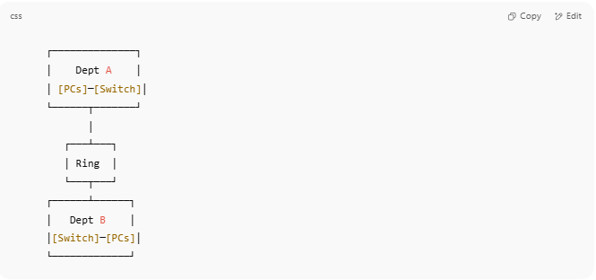

┌──────────────┐
│ Dept A │
│ [PCs]─[Switch]│
└──────┬───────┘
│
┌───┴───┐
│ Ring │
└───┬───┘
┌──────┴──────┐
│ Dept B │
│[Switch]─[PCs]│
└─────────────┘

Each department (or floor, or zone):
- Has a star topology internally.
- Is connected to other departments in a ring.

✅ Advantages
# Source: AI Source: Provided by: [Data Path: Persons Table -> ID Column: 1, Name_En Column: Motasem Essam] -> From: [ChatGPT] on [12/18/2025]
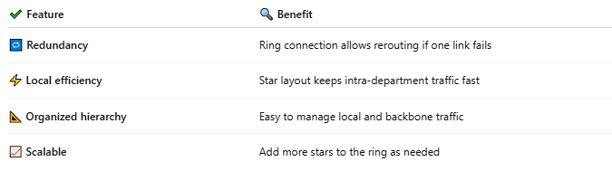

✔ Feature | 🔍 Benefit
🔁 Redundancy | Ring connection allows rerouting if one link fails
⚡ Local efficiency | Star layout keeps intra-department traffic fast
📐 Organized hierarchy | Easy to manage local and backbone traffic
📈 Scalable | Add more stars to the ring as needed

❌ Disadvantages
# Source: AI Source: Provided by: [Data Path: Persons Table -> ID Column: 1, Name_En Column: Motasem Essam] -> From: [ChatGPT] on [12/18/2025]
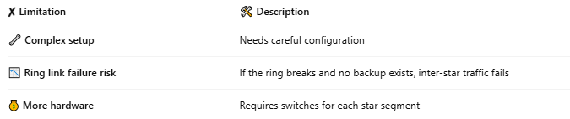
✘ Limitation | 🛠 Description
🔧 Complex setup | Needs careful configuration
📉 Ring link failure risk | If the ring breaks and no backup exists, inter-star traffic fails
💰 More hardware | Requires switches for each star segment

🛠 Where It’s Used
# Source: AI Source: Provided by: [Data Path: Persons Table -> ID Column: 1, Name_En Column: Motasem Essam] -> From: [ChatGPT] on [12/18/2025]
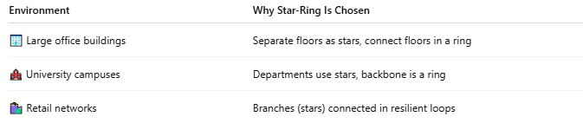
Environment | Why Star-Ring Is Chosen
🏢 Large office buildings | Separate floors as stars, connect floors in a ring
🏫 University campuses | Departments use stars, backbone is a ring
🛍️ Retail networks | Branches (stars) connected in resilient loops

✅ Summary
# Source: AI Source: Provided by: [Data Path: Persons Table -> ID Column: 1, Name_En Column: Motasem Essam] -> From: [ChatGPT] on [12/18/2025]
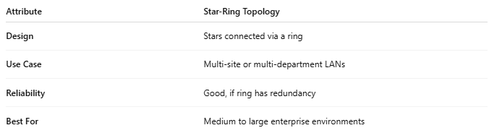

Attribute | Star-Ring Topology
Design | Stars connected via a ring
Use Case | Multi-site or multi-department LANs
Reliability | Good, if ring has redundancy
Best For | Medium to large enterprise environments

